Impact Analysis Document
ECM – Eclipse Integration (Phase 1)

Introduction
Currently all the storage is on-premise and any module in Eclipse that needs document handling references document profile. Document profile in Eclipse define –
- Storage Location – Path where file is stored
- Authorization Key – Controls the accessibility of user.

The proposed enhancement will enable storing documents directly in ECM instead of on-premise file location by mapping each document profile to an ECM content type (folders in ECM). This approach allows existing Eclipse functionality to remain unchanged for users while taking ECM for scalability and centralized management.

In Scope
- ECM Connection Credentials Validation
- Addition of Is ECM Profile flag in Document profile screen
- Grey out non-essential fields when Is ECM Profile is enabled (Keep Title, Description, View Auth Key editable)
- View authorization continues to work as today using View Auth Key.
- On Save, creation of –
  - Document profile record in Eclipse
  - Mapped ECM content type in ECM
  - URL creation to be accessed by companion products like ECC.
- Upload, View, Download, Edit and Delete routed through ECM for ECM profiles.
- Viewable in web – Integration URL creation and storage

Out of Scope
- Changes to View Auth key logic
- Migration of existing on-premises documents to ECM (future phase)
- Eterm changes for creation/editing for ECM enabled profiles
- Document indexer (Bar code scanner) – Future phase
- Bulk upload on images/files to ECM and sync back to Eclipse

Current Functionality
- Storage – Document profile defines a physical file path
- Authorization – View Auth Key determines the visibility
- Usage – Selected during upload referenced by any feature needing document handling
- Limitation –
  - On premise storage limits scalability
  - Manual path management required.

- New Functionality
- Is ECM profile flag for identifying profiles that store documents in ECM
- When enabled – Grey out all fields except Title, Description ,View Auth Key and Viewable in Web . Storage path no longer used, ECM content type handles storage location
- On Save –
  - ECM Content Type (folder) created in ECM via API.
  - Mapping between Document Profile and ECM Content type saved in Eclipse
- All file operations for ECM document profiles go through ECM API (Upload/View/Download/Edit/Delete)

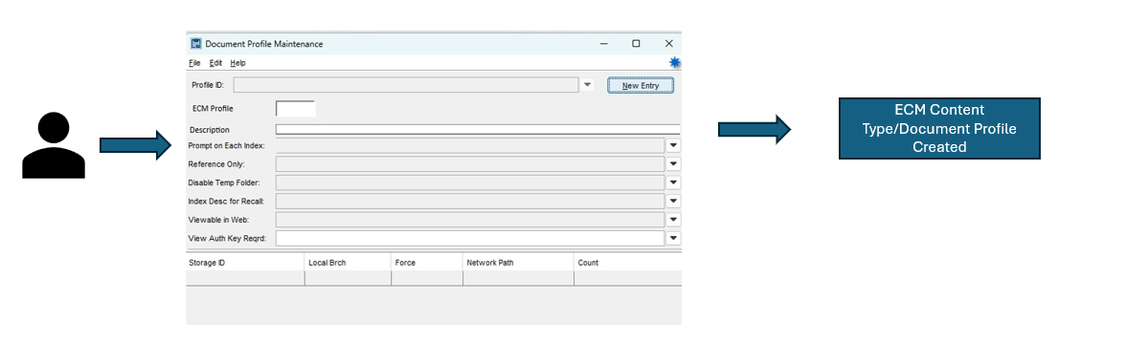

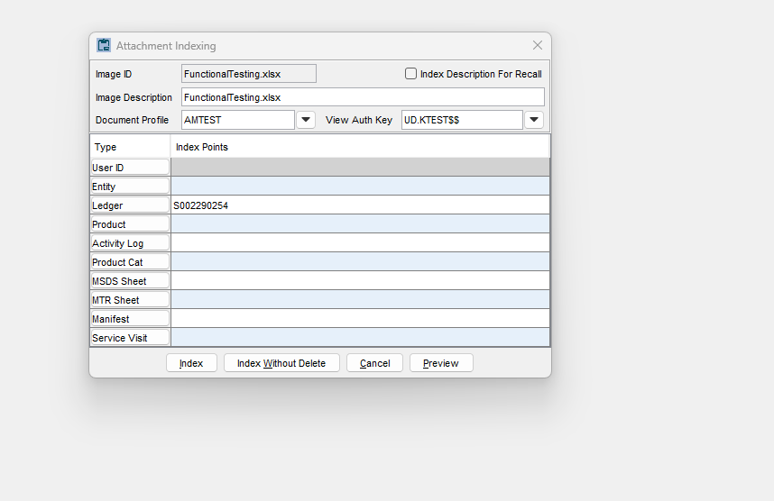

Note- User selects the ECM Document profile ( If ECM is enabled only the document profiles with ECM enabled would be displayed in the Document Profile drop down. View Auth Key would be auto populated with the value selected during the creation on Document Profile.

- Impact Areas

Area | Impact
UI | Document Profile Maintenance Screen - New Is ECM Profile checkbox; grey out storage path and related profiles
Backend | ECM API integration for content type creation ; mapping for document profile and content type
Storage | ECM manages all files for ECM profiles; no on premise path usage. Data stored in content type folders (Created in document profile maintenance screen)
Authorization | No change to view permission logic
Audit | Logging enabled - API Activity logs
Image Purging | No purging functionality as such as the documents are stored in ECM server.
Image Exception Report | Will work as is as the documents are stored in ImageXref.
ECC Integration | Will work as is as the document profile creation is retained. Document profile maintenance screen would act as the screen for creating a internal document profile – content type mapping.
Data Migration | Future Phase

